Methodology for the production of magnetic composites based on ferromagnetic powders

Marcin NABIAŁEK, Bartłomiej JEŻ*

¹Institute of Physics, Faculty of Production Engineering and Materials Technology, Czestochowa University of Technology, 19 Armi Krajowej Str., 42-200 Częstochowa, Poland

Abstract

The article presents a description of the technology for the production of magnetic composites based on amorphous iron alloys for use in electronics and electrotechnics. Technology of producing bulk amorphous materials using injection and suction the liquid alloy into a copper mold was presented. As part of the work, a bulk amorphous alloy with chemical composition Fe₆₂Co₉Y₈W₁B₂₀ was produced using the injection method. On its basis, magnetic composites were produced with the participation of polymer resin in a mass fraction of 0.1%, 0.2%.

Keywords: bulk metallic glasses, soft magnetic composites, injection method, suction-casting method.

Introduction

Ferromagnetic amorphous and nanocrystalline alloys are characterized by so-called good soft magnetic properties i.e. high magnetisation of saturation and low coercive field value [1,2]. Due to low loss during the re-magnetization process, these materials can be used as low-loss transformer cores [3]. Unfortunately, classic amorphous materials, i.e. produced in the form of ribbons or thin films, have limited application due to their geometry. The work of many scientists and in particular A. Inoue resulted in the creation of a new group of materials: bulk amorphous materials [4]. The new production methods and criteria set by A. Inoue enabled the production of amorphous alloys even a few centimeters thick. An interesting group of rapid-cooled materials are bulk iron-based amorphous alloys with good soft magnetic properties [5]. However, these materials still do not achieve satisfactory geometry. Hence, research is conducted to expand the applicability of these materials. One of the possible applications of bulk amorphous materials is the production of so-called magnetic composites. The base of these materials may be, for example, a ferromagnetic powder with different gradations made of iron-based amorphous and / or nanocrystalline alloys [6]. The binder for the ferromagnetic powder may be various types of adhesives, e.g. other alloys or plastics. The filler in the form of a powder is then a much larger share in this material as compared to a non-magnetic / magnetic binder. During the production of this type of magnetic materials, it is important to choose the optimal ferromagnetic ratio of the filler to the binder in a manner that allows maintaining good magnetic properties and improving the shaping of the material. Magnetic composites are already used as magnetic screens, magnetic circuits or magnetic wedges [7]. These materials are usually manufactured by pressing under high pressure (in the order of several hundred MPa) [8]. An alternative to these materials may be cheaper technologies using lower pressures.
The article presents a description of the technology for the production of magnetic composites at low compression pressures based on amorphous iron alloys using a polymer resin as a matrix.
Methodology of Production

The first stage in the production of magnetic composites is the production of a polycrystalline ingot. Such an ingot is obtained by means of arc melting in a protective atmosphere of argon. The alloy components are weighed with an accuracy of 0.0001 grams of elements with a purity of 99.9%. The weighed alloy components were placed in a pocket on a water-cooled copper plate. A high vacuum is obtained in the working chamber, after which the chamber is rinsed with argon and the pumping process is repeated. Such actions are aimed at cleaning the working chamber which has a big impact on the quality of the polycrystalline ingot. Before the right process solidification of the alloy components, pure titanium is melted to absorb the remaining impurities in the chamber. The re-melting of the ingot is repeated several times after each previous reversal, which ensures good mixing of the alloy components. The homogeneity of the polycrystalline ingot has a large impact on the reproducibility in the production of rapid cooled materials.

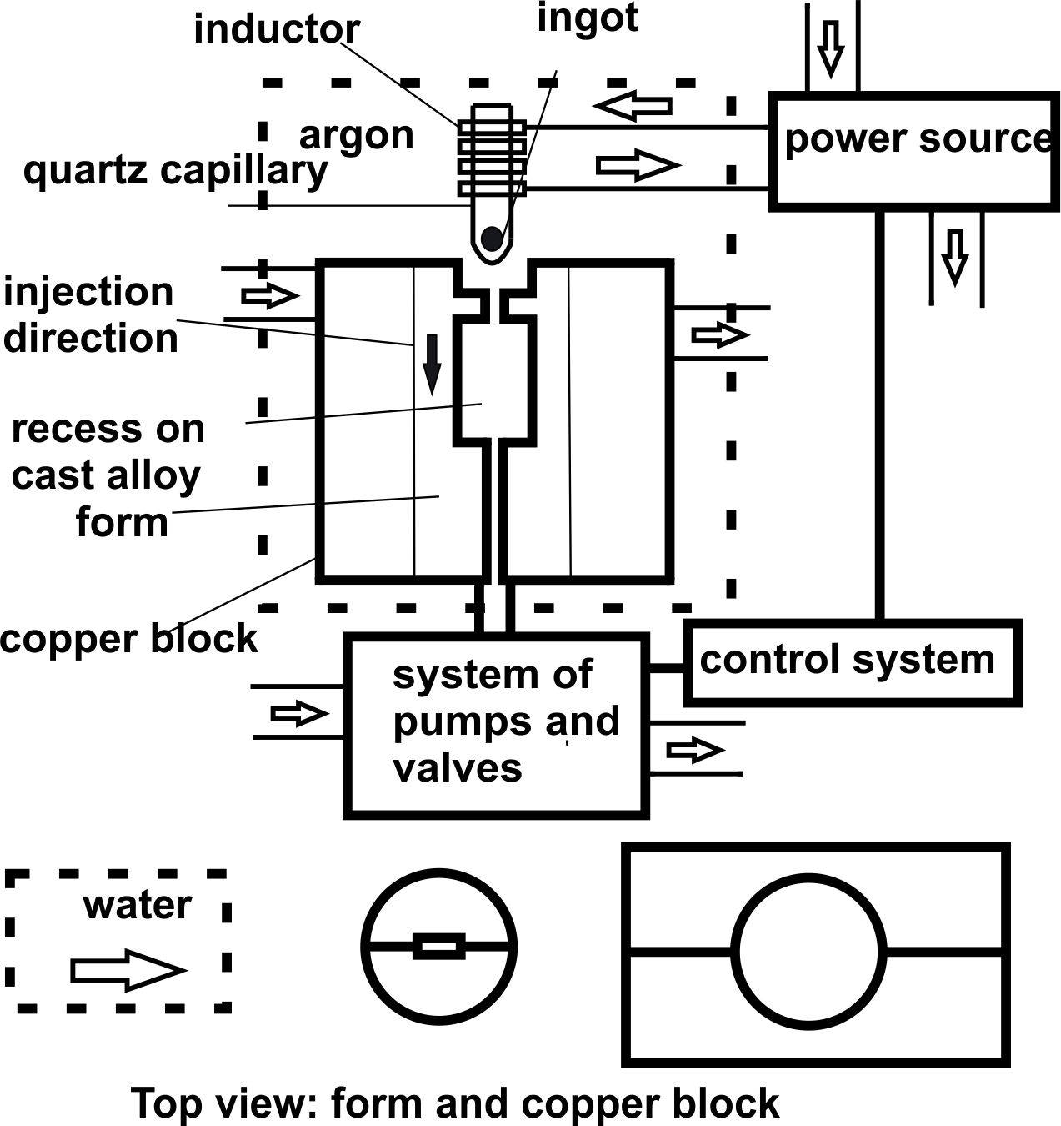

Fig. 1. Scheme of produce amorphous materials using injection casting method

The second stage in the production of composites is production of rapid cooled alloys. The cleaned ingots are used to produce bulk amorphous alloys. There are various methods of producing bulk amorphous alloys. Interesting solutions are: suction and injection the liquid alloy into a copper mold. These methods are characterized by a cooling rate in the range of 10⁻¹ to 10³ K/s. For each of these methods, melting of the ingot is carried out in a different way. The way of placing a molten alloy in a copper form is also different. Fig. 1 presents a scheme for the production of amorphous materials by injection casting method. The batch is placed in a quartz crucible with a 1mm diameter hole. The crucible is placed in the working chamber in such a way that the charge is at the height of the copper coil. The batch is melted using eddy currents. The liquid melt is pressed under a suitably selected argon pressure to the water-cooled copper mold. The entire material production process is carried out under a protective atmosphere of argon. The working chamber has been previously pumped from the air and any contaminants using a pump and valves system. In order to obtain the best conditions, the chamber was subjected to additional argon washing and pumping back. The suction method is characterized by a similar cooling rate, up to 10³ K/s. In this case, the polycrystalline ingot is melted using a plasma arc. At the right moment, the liquid alloy was suction into the copper mold by means of a valve and pumps system. As in the case of the injection method, working chamber was pumped out and flushed with argon to obtain a clean atmosphere. Before the melting of the charge, the titanium getter is smelted to capture the remaining impurities in the chamber. For both methods it is possible to use the same copper forms, the same level of vacuum and the same argon pressure in the working chamber. The basic differences between the methods used are the method of placing the molten alloy in the copper form, the melting method of the material and the use of the titanium getter in the suction method.

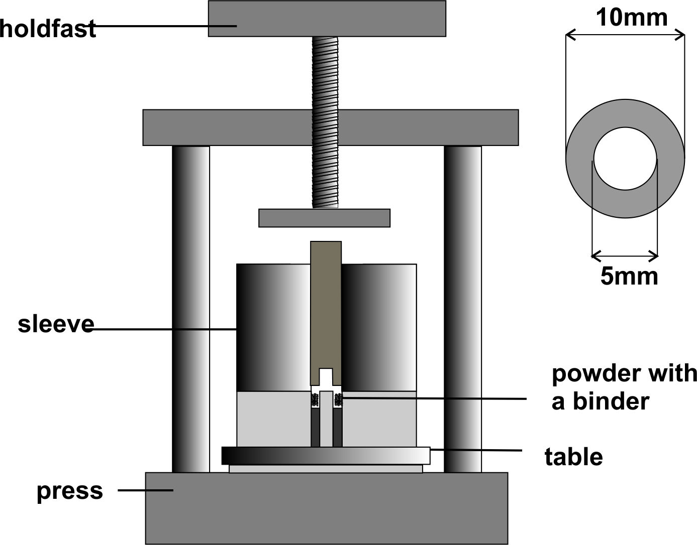

Fig. 2. Schematic representation of producing magnetic composites on a hydraulic press

Produced materials after the structure tests and possibly magnetic properties are subjected to low energy milling. The obtained ferromagnetic powder can be used to make a magnetic composite. Typically, the powder is divided into fractions. The size of the grains of ferromagnetic powder has a significant effect on the magnetic properties of the composite [9]. Composites are manufactured using a hydraulic press. The scheme for the production of magnetic composites is shown in Fig. 2. The mixture of ferromagnetic powder and resin is placed in a suitably prepared form. If a chemically hardenable resin is used, an appropriate chemical agent is added to the mixture. For composites made using a thermo hardenable resin, acetone is added to the mixture for better mixing of ingredients. The batch is pre-pressed with a clamp. After blocking the mold, pressing takes place using a hydraulic system. The press allows ironing with pressures up to 30 MPa. Specially prepared form enables the production of toroids with dimensions: outer diameter 10mm, internal diameter 5mm and thickness up to 6mm. In the case of thermo hardenable resins, the toroids are subjected to annealing in an electric furnace at a temperature of about 50 - 100 ° C for a period of about 1-2 hours.

Material and Methodology of Research

An alloy with chemical composition Fe₆₂Co₉Y₈W₁B₂₀ was designated for research. Polycrystalline 10 grams ingot was produced using an arc furnace. Alloyed components with a purity of 99.99% were used. The rapid cooled alloy was produced by injection a liquid alloy into a water-cooled copper mold. The material was cast in the form of a 10 x 5 x 0.5 mm plates. Produced material was mechanically cleaned and using an ultrasonic cleaner. The alloy was subjected to low energy milling. The ferromagnetic powder was mixed with a Duracyl plus chemically hardenable resin. Magnetic composites were produced using uniaxial pressing. Table 1 presents the parameters for the production of magnetic composites.

Table 1. Parameters for the production of magnetic composites

Sample number | Resin content | Pressing pressure | Pressing time | Sample thickness
1 | 0,1% | 22 MPa | 0,5 h | 4 mm
2 | 0,2%

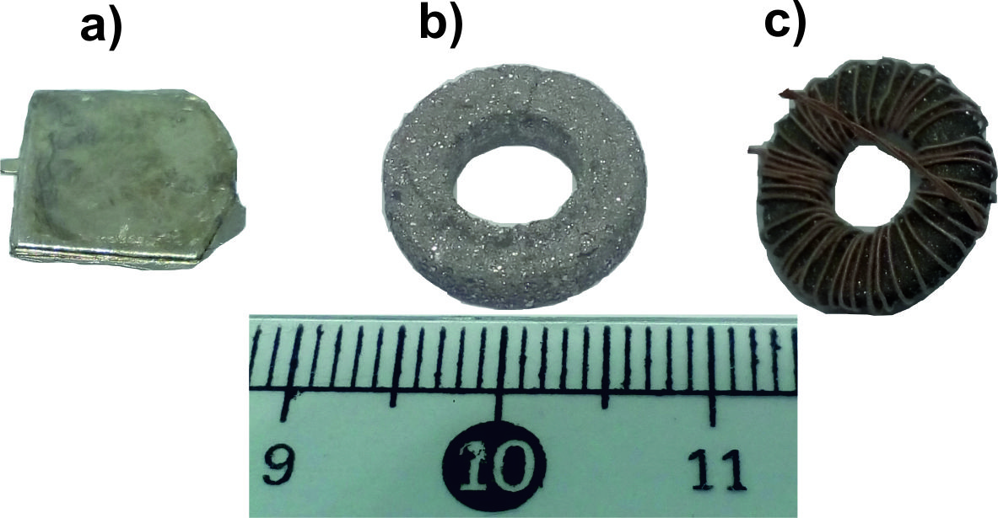

Fig. 3. Fe₆₂Co₉Y₈W₁B₂₀ alloys produced: a) solidified state, b) 0.2% resin composite,
c) 0.2% resin composite with measuring coil

The composites produced were subjected to an organoleptic strength test. Composites containing 0.2% resin were characterized by good strength. The material did not crumble during winding the coil test to measure magnetic properties. In the case of a composite with a 0.1% resin content, attempt winding the coil was unsuccessful. Fig. 3 presents photos of the produced samples in the state after solidification and in the form of a composite.

Conclusions

The unique magnetic properties of iron-based amorphous materials are still not fully utilized. The limited geometry of the samples produced does not allow the application of these materials in many branches of electronics and electrical engineering. Magnetic composites are already used in industry, but they are usually produced by sintering or pressing under very high pressure. The production of composites based on amorphous iron alloys with the use of low compression pressure may turn out to be a much cheaper and useful technology. These materials will probably be characterized by poorer magnetic properties than those produced at higher pressures, however, they can be used especially when the price of the material is an important factor. Preliminary tests indicate the possibility of producing magnetic composites using low compression pressure (on the order of 20 MPa) with a low content of non-magnetic binder (0.2%). In order to confirm the usefulness of this producing method of materials for use in electrical engineering and electronics, it is necessary to carry out structure and magnetic properties tests.

References:
[1] M.E. McHenry, M.A. Willard, D.E. Laughlin, Amorphous and nanocrystalline materials for applications as soft magnets, Prog. Mater. Sci., 44, 1999, pp. 291.
[2] Y. Han, C.T. Chang, S.L. Zhu, A. Inoue, D.V. Louzguine-Luzgin, E. Shalaan, F. Al-Marzouki, Fe-based soft magnetic amorphous alloys with high saturation magnetization above 1.5 T and high corrosion resistance, Intermetallics, 54, 2014, pp. 169-175.
[3] K. Brzozka, A. Slawska-Waniewska, P. Nowicki, K. Jezuita, Hyperfine Magnetic Fields in FeZrB(Cu) alloys, Material Science and Engineering A, 226-228, 1997, pp. 654-658.
[4] A. Inoue, Stabilization of metallic supercooled liquid and bulk amorphous alloys, Acta Materialia, 48, 2000, pp. 279-306.
[5] M. Nabialek, K. Jez, The Influence of the Manufacturing Method on the Structure and Magnetic Properties of Rapid Cooled Iron Based Alloys, Revista de Chimie, 69(6), 2018, pp. 1593-1597.
[6] C. Wu, H. Chen, H. Lv, M. Yan, Interplay of crystallization, stress relaxation and magnetic properties for FeCuNbSiB soft magnetic composites, Journal of Alloys and Compounds, 673, 2016, pp. 278-282.
[7] T. Janta, Wpływ temperatury pracy na właściwości magnetyczne dielektromagnetyków, Zeszyty problemowe – Maszyny Elektryczne, 75, 2006, pp. 171-175.
[8] C. Xia, Y. Peng, Y. Yi, H. Deng, Y. Zhu, G. Hu, The magnetic properties and microstructure of phosphated amorphous FeSiCr/silane soft magnetic composite, Journal of Magnetism and Magnetic Materials, 474, 2019, pp. 424–433.
[9] M. Nabiałek, K. Błoch, M. Szota, A.V. Sandu, Structure and Magnetic Properties of Composite Toroids Powder Casted, Materiale Plastice, 54(3), 2017, pp. 491-494.
____________________________________

Received: January 10, 2019
Accepted: March 22, 2019

